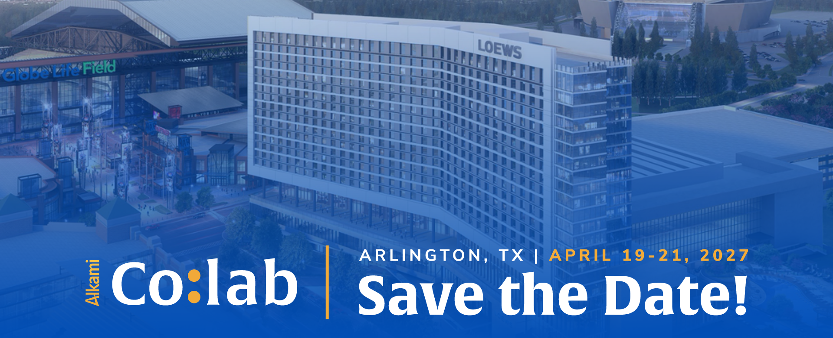

Instructions: Customize or delete everything in pink, and don’t forget to delete this line before sending or printing, too!

Suggested Email Subject Line: Here is why I can’t miss Alkami Co:lab

Hello [Your boss’ name],
I am writing to you today seeking your approval to attend Alkami Co:lab 2027 in Arlington, Texas, from April 19-21. Alkami’s industry-leading banking technology conference is held each year, inviting the best and brightest minds in consulting, financial services, fintech and industry analysis to inform and inspire banking leaders, like me.
I believe Alkami Co:lab would be a worthwhile inclusion to my professional development plan for the year. Take a look at the recap of 2026’s conference to see the high-quality experience Alkami delivers, and learn more about the valuable education I can expect as an attendee.
Many of our partners attend, including [insert partner or remove] and [insert partner or remove], leading sessions and demonstrating their latest products and solutions. Alkami is also hosting meetups by Core, it would be really nice to meet others who use [insert core or remove]. Maybe I could even get an answer for us on how to handle [insert a particularly irksome problem your team has been having].
Here is an approximate breakdown of the cost for my trip:
$000 Airfare (search your home airport to DFW for estimated)
$120 Ground Transportation (ride share such as Uber) to/from Airport/Hotel
$807 Loews Arlington Hotel & Convention Center (3 nights - room+tax per night)
$1,695 Conference Pass (this will include most of my meals)
TOTAL = [Insert Total] Plus, if I register by December 15th, we’ll save $100.
After attending, I’ll gladly share with you and the rest of the team all of the resources, key takeaways, skills and inspirations, and how they can be applied to our current and future strategies. Alkami makes it easy by sharing all of the presentation decks with attendees right after.
Thank you for considering my request. I look forward to your reply.
Sincerely,
[Your Name]

